**ASSIGNMENT 15.5**

**Problem Statement:**

Build and Deploy Hadoop word count program using SBT

Note: You can use any program of your choice

**Solution**

**SBT build:**

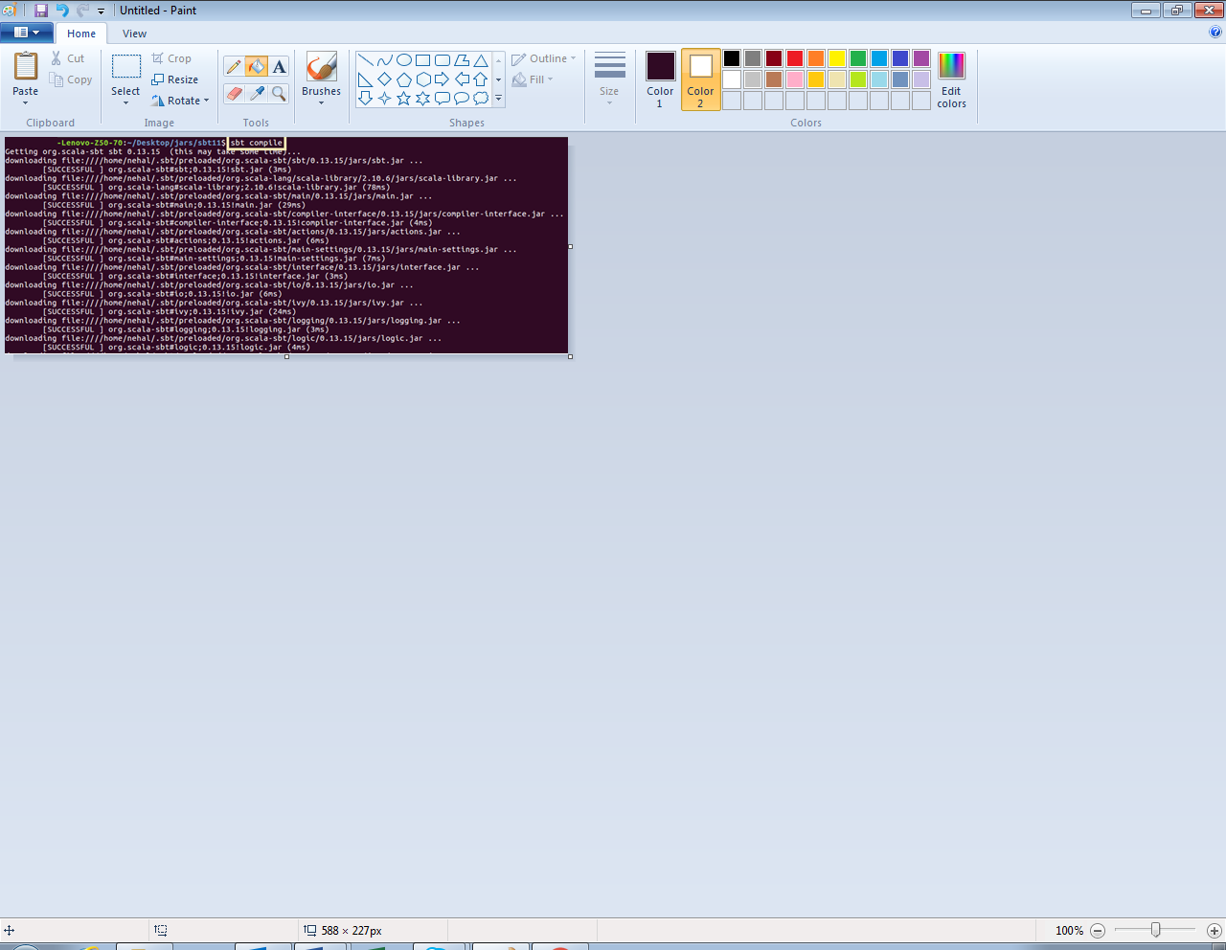

**SBT build file:**

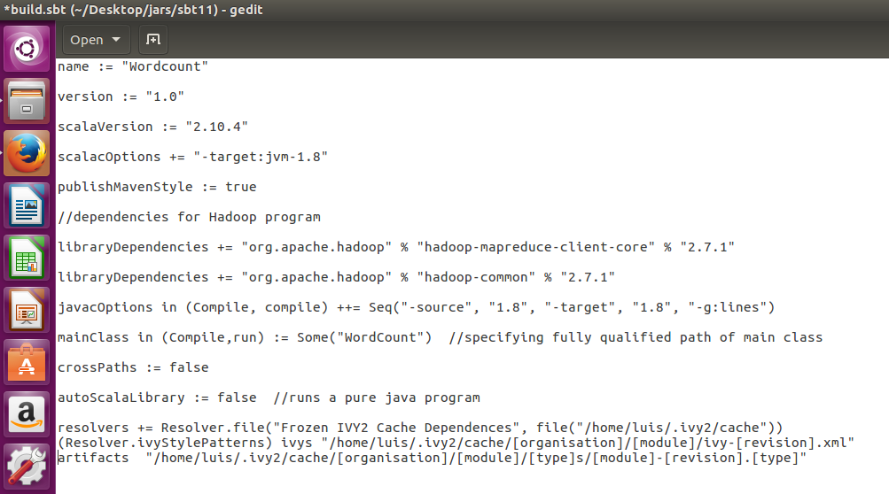

**Word count program:**

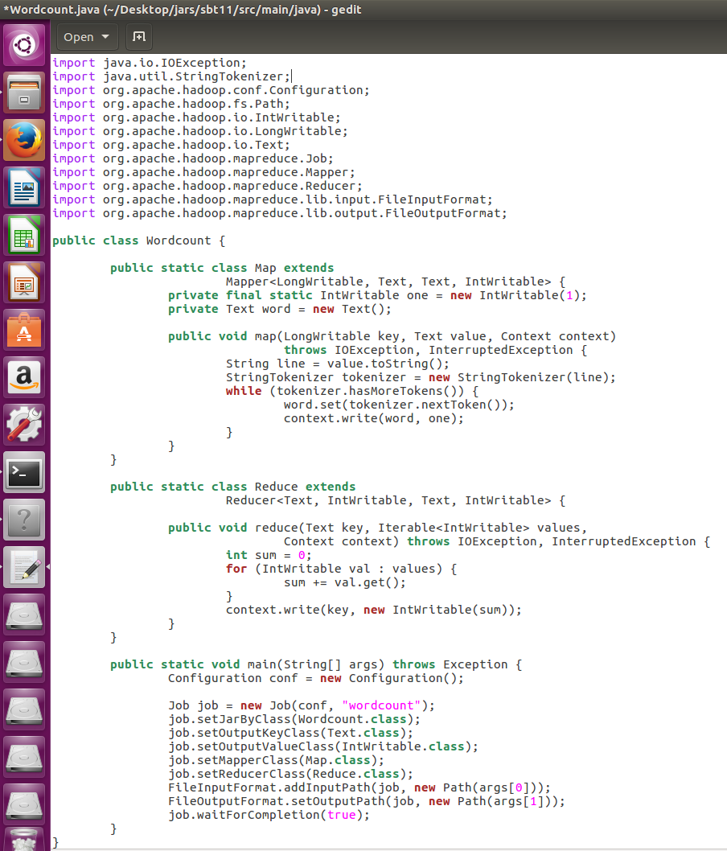

**Dataset:**

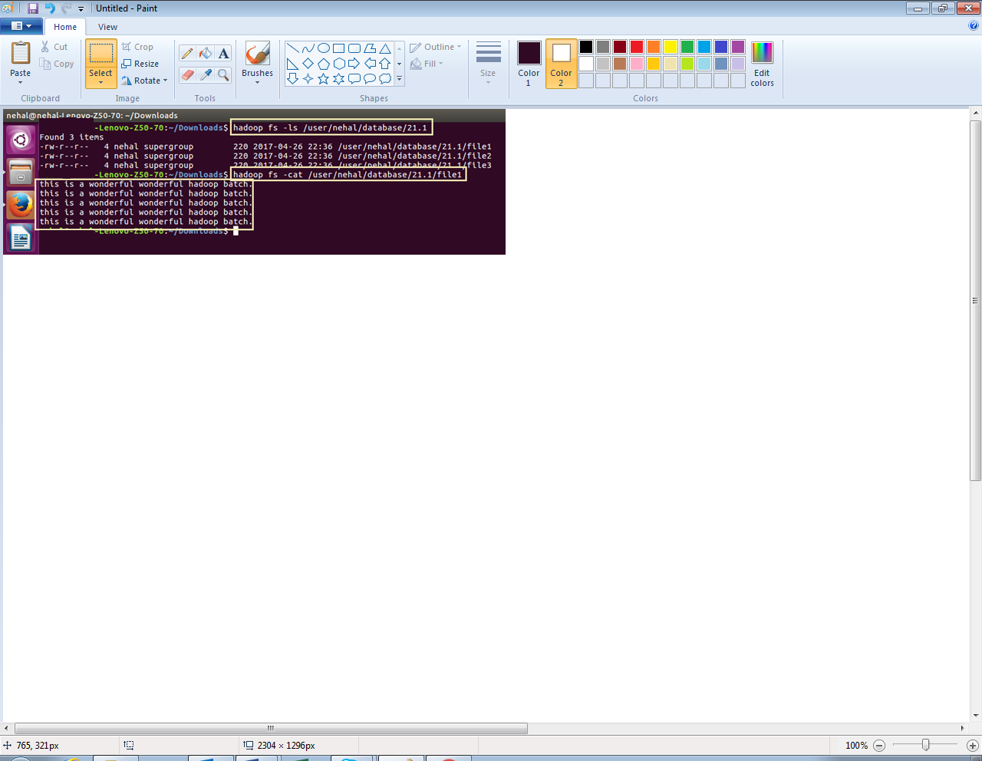

**Running SBT project (jar file):**

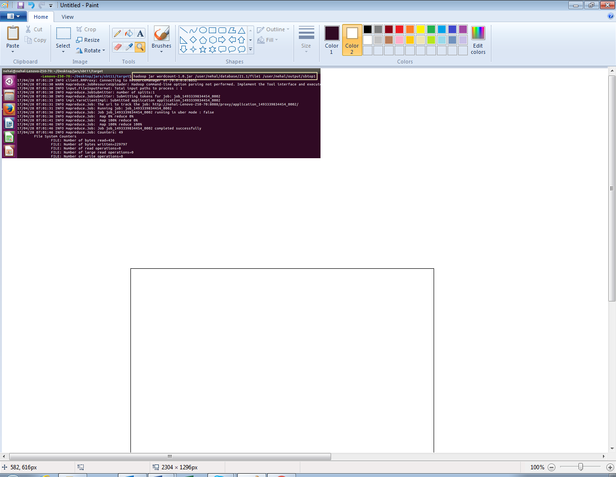

**Output:**

